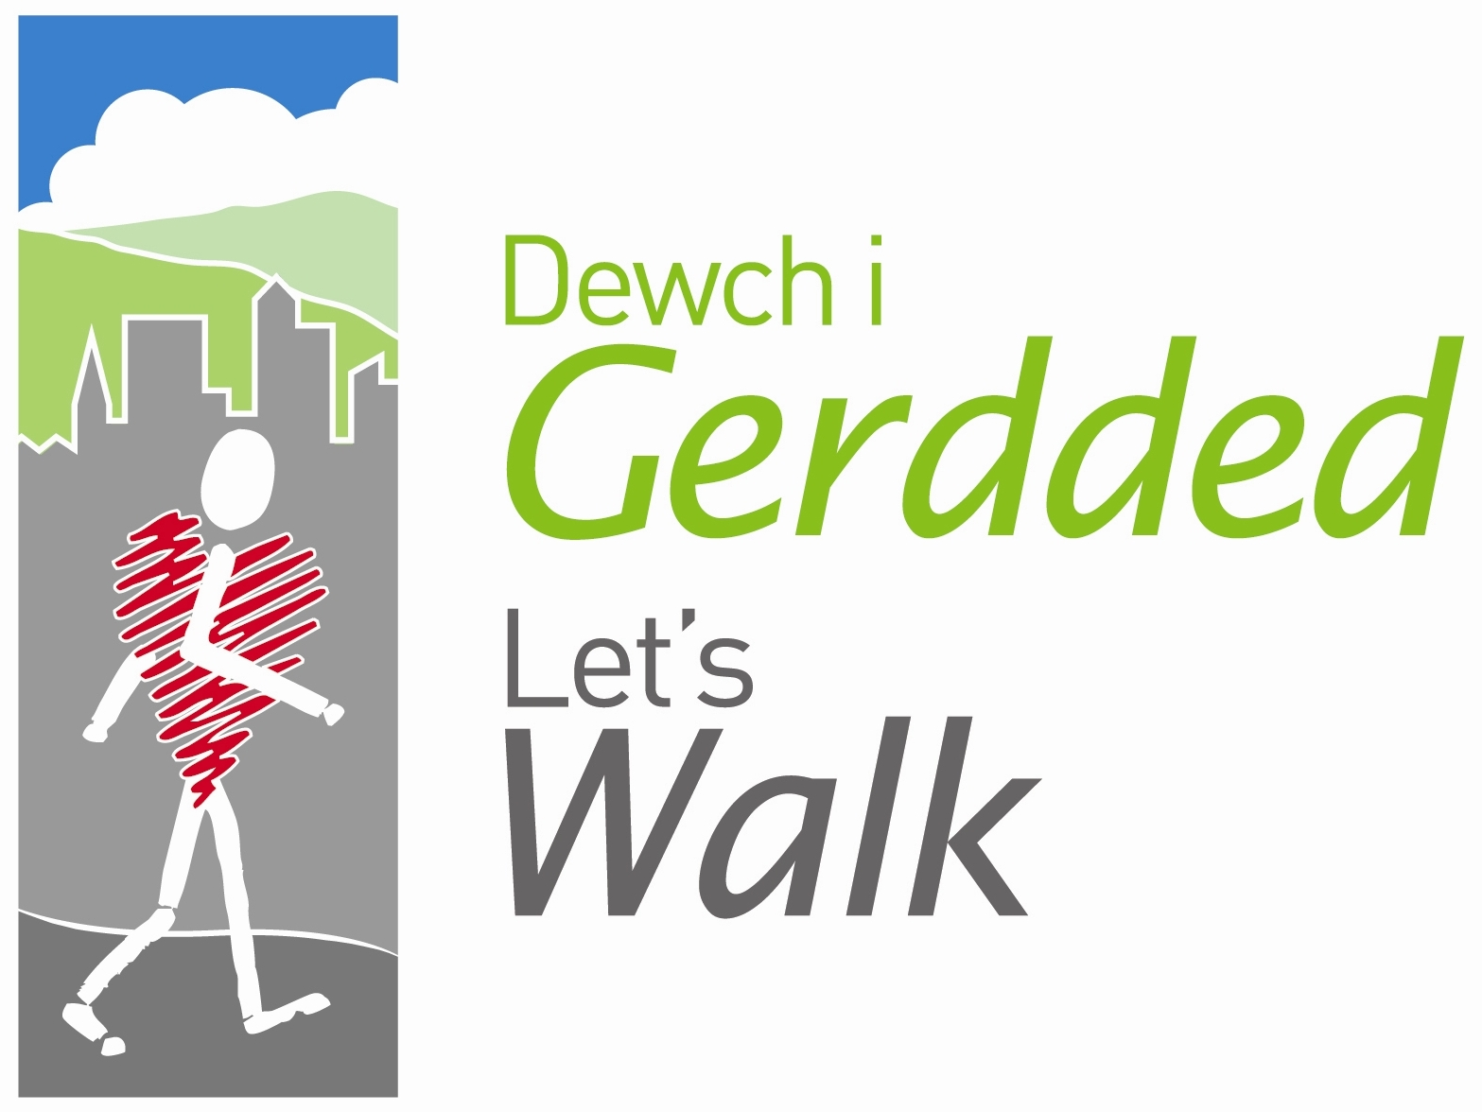
Walk Register

Date: ………………………………………… Time: ……………………

Leader/s: ………………………………………………………………………………………..……...

Location: ……………………………………………………………………………………………….
 | First name | Surname | New walker | CTH
Please PRINT your name
1
2
3
4
5
6
7
8
9
10
11
12
13
14
15
16
17
18
19
20
21
22
23
24
25

CTH = CHANGE TO HEALTH - If there is any change to a walkers health since the last completed questionnaire, please ensure that a Health Walk Questionnaire is completed.

Weather conditions: ……………………………………………………………………………………………
………………………………………………………………………………………………………………………
General comments: …………………………………………………………………………………………….
………………………………………………………………………………………………………………………

